
INDBANK MERCHANT BANK

HOME
8/26/2008
CMP | Rs 18.2
Face Value | Rs 10
Market Cap | Rs 77.88 crore
52 Week high | low-Rs 52.3/Rs 15
Avg daily volume | 12000
PE Ratio | 2.25
P/BV | 0.70
DIV | 15%
DIV YIELD | 8.24%
BRIEF HISTORY:
Indbank Merchant Banking Services Limited (Indbank) had its genesis as a Merchant Banking Division of Indian Bank in 1982 to provide specialized Merchant Banking and allied services. The division had managed 133 issues for an aggregate value of Rs.2250 crore between 1982 and 1989. The division was also involved in investor education programs in various centers across the country.
Indbank was incorporated as a wholly owned Subsidiary of Indian Bank in 1989 to take over the business of Merchant Banking division of Indian Bank and to undertake other specialized activities like Leasing, Hire Purchase etc which banks were permitted to undertake only through their subsidiaries. Indbank was one among the few subsidiaries to be formed by nationalized banks for
Undertaking Merchant Banking and allied services.

Promoters
Indbank was promoted by Indian Bank, which was among the first native banks to be incorporated in south India in 1907. Indian Bank was nationalized in 1969. Indian Bank is also the promoter of Indian Bank Mutual Fund (a trust) for mutual fund activities, Indbank Housing Limited (along with HUDCO) and Indfund Management Ltd. (Asset Management Company for Indian Bank mutual fund).
Business & Activities
Indbank as part of fee based activities is engaged in: (I) Merchant Banking & Advisory Services (II) Stock Broking( III) Depository Participant Activities (IV) Distribution of Mutual Fund & other investment products
COMPANY EARNING:
Company has shown CAGR of 79.82% in past 3 years on YOY basis. This happened due to the good market condition as company is basically in merchant banking business.
Net sales yoy basis:
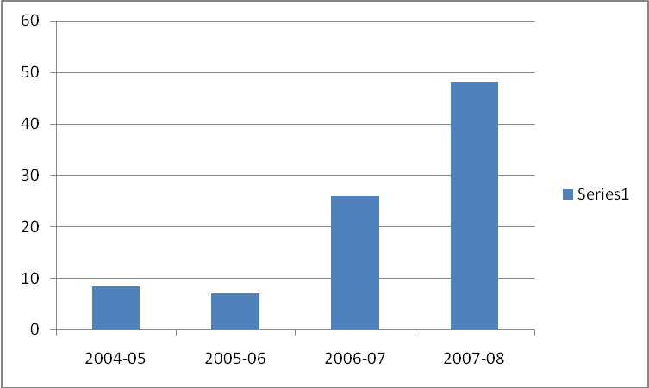

INDBANK MERCHANT BANK

HOME

In the previous some quarters pressure is seen in net income due to the turmoil in financial market.
Net sales on quarterly basis:
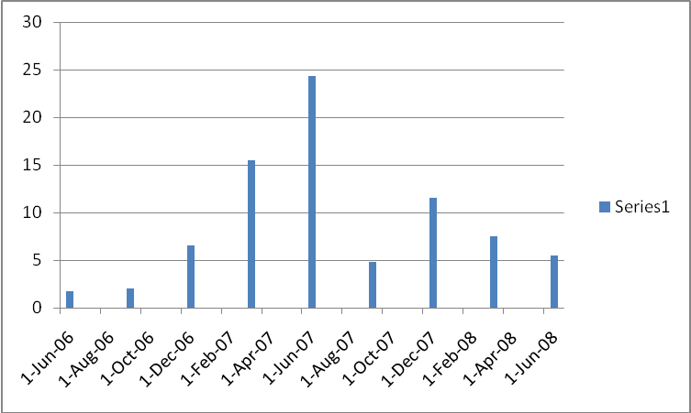

Companies’ net profit margin has increased YOY basis from 19.06% in 2004-05 to 71.73% in 2007-08.

INDBANK MERCHANT BANK

HOME

Net profit margin yoy basis:

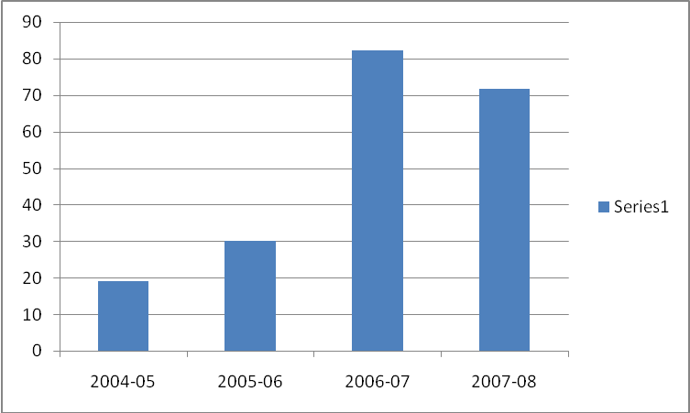
Companies PAT has shown CAGR of 180.2% in past 3 years.
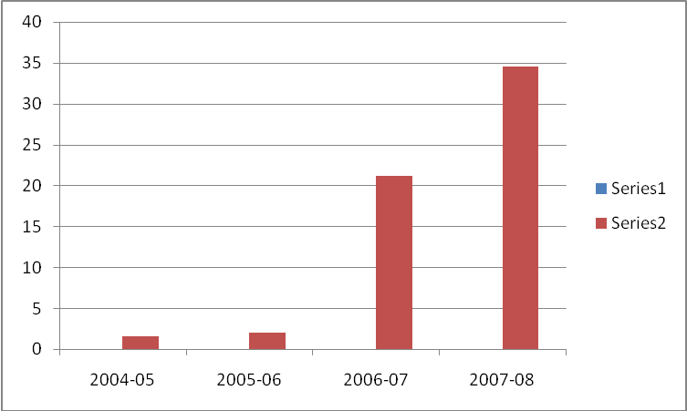

INDBANK MERCHANT BANK

SHARE HOLDING PATTERN: 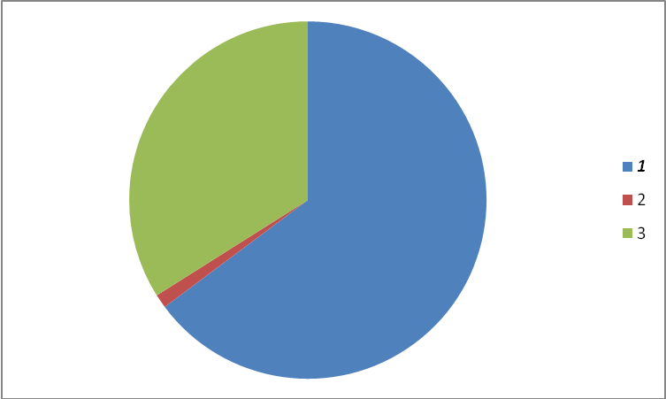
Promoter-64.8%
Mutual fund-1.25%
Public-33.95%

VALUATION:
Indbank merchant bank is right now trading at PE of 2.25, which is much below the industry average of 6 on conservative basis. At this multiple of 6, company seems to be undervalued.Fair value should be any at around Rs 45.

INDBANK MERCHANT BANK

CONCERN:
As company is operating in financial sector, the tough condition prevailing in the financial market could hit its top line and bottomline.Net profit margin could be under severe pressure.
CONCLUSION:

All the negative news is supposed to be factored in the stock’s price, downside limited on this counter. Company has good track record of paying dividend.Div yield at this price is about 8%.This div yield could help in sustaining the price even if market tumbles.
My view is one should take contrarian call on this stock and keep on accumulating it at this level.

Happy investing.

